This document is to help you prepare for your first customer interactions to present NeVa correctly and impactfully. Please use the talk track as a suggestion and feel free to convey the key messages in your own words.

SLIDE | GOAL & NOTES |  | SUGGESTED TALK TRACK
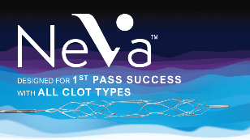 | Ice breakers  Time to set expectations |  | Dear Dr X / Drs X, Y, Z,  Many thanks for allowing me this time to present you NeVa.  The presentation itself should take no longer than 10-15 minutes of your time, and I will be happy to answer any questions you may have along the way or afterwards.
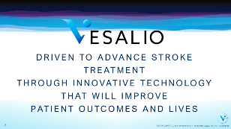 | Provide backgrounder on VESALIO.  Introduce your company as well. (Add any relevant information on how your company and VESALIO goals align in this instance.) |  | NEVA is brought to you by VESALIO, a US based neuro-vascular company dedicated to advancing stroke treatment through innovation with the goal of improving patient outcomes and lives.  As, YOUR COMPANY NAME, we have been partnering with VESALIO since DATE.  NEVA is a prestigious addition to our portfolio with its innovative design and with the opportunity it provides to work within the very exciting field of neuro-intervention.  Together, we are looking forward to having you on board with us, evaluating our technology and giving us your feedback.
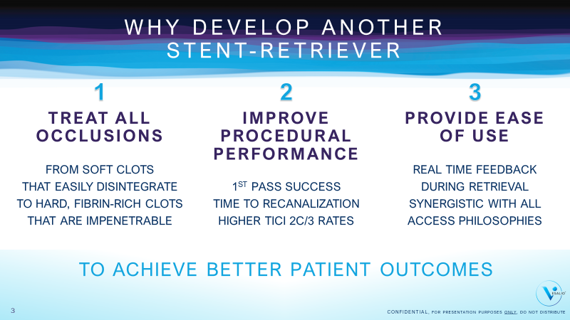 | Provide the rationale behind the development of NeVa.  This and next slide will allow you to confirm the unmet needs, i.e. shortcomings of current stent retriever designs.  Look for signs of agreement in the body language of your audience. |  | Why develop another stent retriever…  We are entering a space that already has several products that look similar and behave with the same mechanism of action. Some customers we met initially seemed satisfied with these.  It is a fact that second-generation stent retrievers allowed thrombectomy to be established as the new gold standard in acute stroke treatment. However, these devices were developed from technologies that were not developed for this procedure and therefore have some shortcomings: They are successful with certain types of clots, but with others, they run into problems.  For example, when clots are very soft and disintegrate during retrieval, you get cases of distal or new territory embolization and you end up with a less than ideal recanalization result. Even worse, as clots get harder, they get impenetrable by these devices. So, some clots just slide over the outer surface and simply remain in place.  This was the first observation that triggered the design of NeVa.  The second item on the list was to improve procedural success. Vesalio wanted to develop a device that would get the full clot out with a single pass as often as possible and hence shorten time to recanalization.  If they could indeed come up with a device that would have the capability to incorporate and retain all clot types inside the device and do this in less number of passes, then this would be a device that would help improve recanalization success and outcomes.  Finally, they wanted the device that they developed to give useful, actionable information during the critical retrieval phase and be synergistic with different access philosophies.  I may share with you that the designers of NeVa are interventionalists themselves and lived these frustrations on a daily basis. And hence, they wanted to create a device that had the means to deal with all clot types, a device that would work the first time, every time.  So this is the ambition that NeVa has today.
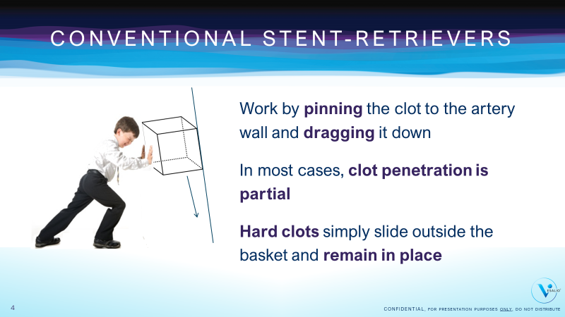 | Provide the rationale behind the development of NeVa.  This and previous slide will allow you to confirm the unmet needs, i.e. shortcomings of current stent retriever designs.  Look for signs of agreement in the body language of your audience. |  | In order to reach this goal, they looked at the principle mechanism of action of standard stent retrievers.  The conventional SR designs work by pinning the clot to the artery wall, much like a fork would pin into a morsel of food and dragging it down until the catheter where the clot and the device will be collapsed.  In most cases, clot penetration is partial, which is part of the problem, but more importantly, Hard clots simply slide outside the basket and remain in place.
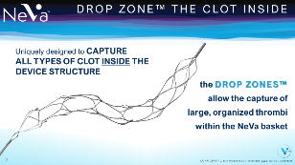 | Provide the most differentiating element of NEVA: The DROP ZONE™ Technology  Capture attention by telling them that the “feature” presentation will be very brief. |  | So how is NeVa different?  I will tell you a little bit more about the design in a couple of slides and then immediately show some performance figures from pre-clinical and clinical performance.  NeVa has DROP ZONES:  Drop Zones are “clot pockets” or large openings opposing one another at 90°. They are designed to integrate the types of clots that will resist to traditional stent retriever design.  Drop Zones do not work by expansive radial force entangling into the clot structure. They do not need radial force. As the name implies, clot will drop into these zones during retrieval.  Because of this different mechanism of integrating clot, NeVa, as you will see in a couple of slides, indeed has a much higher success rate with those challenging clot types that are traditionally impenetrable by standard stent retrievers.
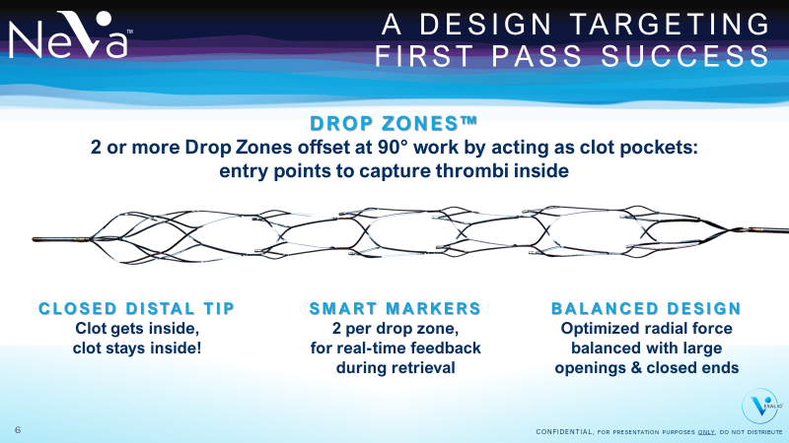 | Provide the key differentiating elements of NEVA design. |  | Apart from the unique Drop Zones, NeVa has:  - A BALANCED DESIGN:  Optimized radial force for good wall apposition throughout the retrieval balanced with large openings that limit the amount of strut in touch with the arterial wall  - SMART MARKERS:  At the leading edge of each of the Drop Zones, these markers give actionable feedback during retrieval.  - CLOSED DISTAL TIP:  To ensure that clot incorporated into the basket will be retained throughout the retrieval phase and avoid distal embolization issues.
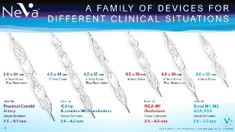 | Show NeVa portfolio, start engaging for the evaluation/ sale.  If you feel it is not the right time to go into the detail of the portfolio, skip these two slides to come back to them at a later point. |  | More on the NeVa portfolio:  We currently propose to 6 devices with different sizes.  (Go through the sizes and recommended locations for use.)  Note that we do not expect you to hold stock of all sizes but a selection of them. We can discuss this more at the end of my presentation if you like…
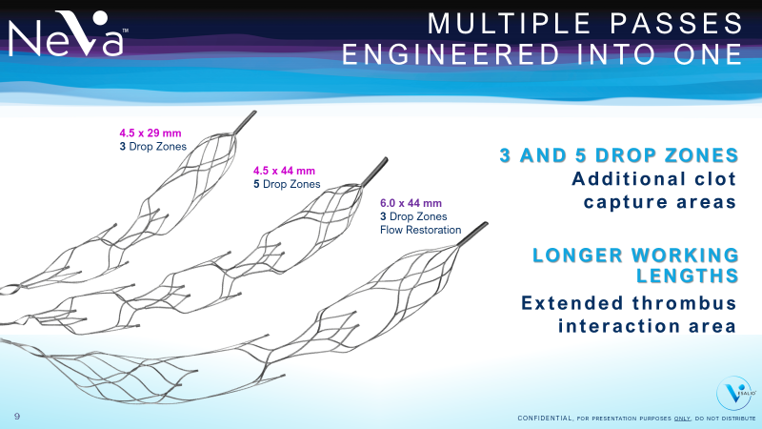 |  |  | The additional 3 sizes of NeVa were added in as a response to physician input.  - One of the first feedback we got as we introduced NeVa was that there was a need for a 6.0 mm device for very proximal occlusions. Our 6 mm NeVa will be for very proximal, ICA bifurcation level occlusions. We believe it has a place in the arsenal, but it will probably be the least used size, for these special, high clot burden, proximal cases.  - We also got feedback that longer working lengths can help get even higher first pass rates. Therefore, we introduced the 5 Drop Zone NeVa and we believe it will be very efficient for high clot burden situations in the distal ICA.  - Finally, the 3 Drop Zone NeVa (4.5 x 29mm) is introduced due to the success of the small 4.0 x 22 mm NeVa.  We believe the 3 drop Zone 4.5 x 29 mm NeVa may become the standard go to product for the majority of cases while the 5 Drop Zone might eventually replace the standard 4.5 x 37 mm size.
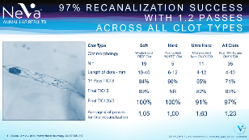 | Provide proof, convince!  Point out:  The challenge given to NeVa was harder than what would be normally encountered in real life (long clots, high % of hard & ultra-hard clots) and yet the results were impressive  Performance on soft clots is already excellent (point especially to 1st pass TICI 3 rate)  Performance on hard & ultra-hard clots was also amazing |  | Now, as promised, some facts and figures.  This first data is from animal testing done immediately before commercialization.  The data is published in Interventional Neurology if you want to check details.  It shows that NeVa achieved 97% recanalization with 1.2 passes on all types of clots.  Let’s look at details…  Since the goal of NeVa design was to deal with all clot types and since designers knew that traditional retrievers failed with harder clots, this animal testing was designed as a challenge to test the performance of NeVa.  As you can see, they created soft/normal, hard and ultra-hard clots off various sizes. Some of the clots were bigger than 1cm.  Also note that about half of the clots used were hard or ultra-hard (46%), which is probably more than the normal proportion of hard clots you’d get in a usual patient series.  The hard clot challenge was made this intense on purpose, to see if the concept would work. And…the results were very encouraging.  (Go through the figures, line by line if you have time, concentrate on the totals column if you’re lacking time…)  In summary, you could say that in this animal testing NeVa achieved:  - 100% recan at 1st pass with “normal” and “hard” clots  - Above 90% recan at 1,63 passes with ultra-hard clots made of Onyx500  - In fact, in the whole range, there was only one 12mm long clot that NeVa missed. All others were all removed in an average of 1.2 passes.  This was quite encouraging.
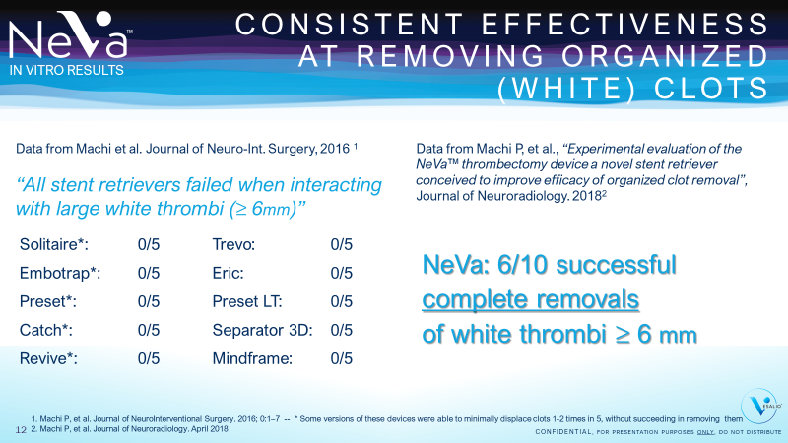 | Provide proof, convince!  Explain the two studies and point to the fact that their design is identical.  Explain that the 2016 study on competitor devices was done on all clot types, but on this table, we pulled out only the large white (bigger than 6 mm) clot data to make things comparable.  Take time to make sure audience follows you.  Re-assure by telling them both studies are published, and you can send full text to them should they want to see the figures with their own eyes. |  | The second piece of data I want to share is bench testing done by Prof Machi in Geneva.  Prof Machi has already done and presented quite intriguing data on stent retriever performance with different clot types. He is one of the leading names that established our understanding of the behavior of stent retrievers and the way they interact with different clots.  He did this by recreating flow model conditions as close to real life as can be possible and by testing every single stent retriever device available on the market in the same way, under the same conditions. HE created 2, 4 and 6 mm soft and hard clots and made 5 pulls with each type with each device.  He showed that with hard clots bigger than 6 mm, conventional stent retrievers failed to remove clots systematically. A couple of the larger devices were able to minimally displace some of the clots without being able to remove them. Others had no effect on these clots at all.  This study is published in the Journal of Neuro-Interventional Surgery in 2016 if you’re interested in the details.  On the left-hand side of this slide, you can see the list of stent retriever brands that were tested.  Now compare this to what happened with NeVa.  Prof Machi created the same conditions to test NeVa in the same manner. Same model, same materials, same clots.  NeVa was able to fully remove 6 out of 10 of the larger than 6 mm hard clots, clearly superior to the performance of standard designs. Thanks to this bench testing we were even more confident that our design will deliver its promise.  This study also got published in the Journal of Neuroradiology and I’ll be happy to pass it on if you’re interested in reading the full article.
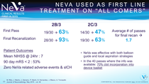 | Provide proof, convince! |  | Obviously, we are aware that these promising results need to be confirmed with real life clinical data.  The next slide I will share with you is from the first 30 patients that were treated with NeVa.  The data came from 4 centers in Spain and Switzerland and the cases had no specific inclusion criteria. In other words, any patients that was treated by hospital protocol was accepted into the analysis which meant we had all types of cases, like tandem occlusions, basilar cases, and even a case with direct carotid access in the analysis.  The recan rates were remarkable with TICI 2c/3 at 63% and TICI 2b/3 at 93%. What is even better is that these final recan rates were obtained with 1.7 passes on average and using NeVa as the only device.  First pass rates, which is what we are very interested in, showed that almost 1 time out of two, near full or full reperfusion was possible in a single pass.  We also looked at clot incorporation in the basket because this is an endpoint that we are particularly interested in and once again, we were happy to see that NeVa incorporated clot 70% of the time.  There were no device-related complications
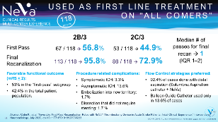 | Provide proof, convince! |  | This slide shows data from a multi-center experience of NeVa first line use on “all comers” again. This 118-patient data is published in Interventional Neuroradiology in July 2020.  The cases had no specific inclusion criteria with several basilar and tandem cases and both very proximal and rather distal occlusions. Most patients were treated with aspiration and SR together and some were treated with a balloon guide catheter as flow control strategy.  The recan rates were remarkable with final TICI 2b/3 at 95.8% and final TICI 2C/3 at 72.9 %. What is even better is that this recan rate was obtained with a single pass most of the time as mediam pass was 1 and the inter quartile range was 1 -2.  First-pass recanalization rates were also in line with the FIM study with 45% perfect or near-perfect recanalization in the first pass and 57 % TICI 2B/3.  Patient outcomes and safety /complications data were also in line with expectations, with slightly better intra cranial hemorrhage rates than what has been observed in other stent retriever patient series in literature.
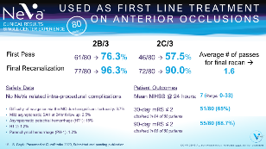 | Provide proof, convince! |  | Finally, this slide shows data from a single center experience from Istanbul.  The 80-patient data was presented at the iCureStroke meeting this year (2020 Feb). The paper is submitted for publication.  The cases had no specific inclusion criteria apart from being in the anterior circulation. Longer time window and difficult access cases were part of the analysis.  The recan rates were remarkable with TICI 2c/3 at 90% and TICI 2b/3 at 96.3%. What is even better is that these final recan rates were obtained with 1.6 passes on average.  As for first pass rates, this experience confirmed once again that 1 time out of two, near full or full reperfusion was possible in a single pass.  There were no NeVa related intra-procedural complications and a few, largely asymptomatic micro-bleeds were observed. Patient outcomes were very positive with a 9-point average improvement on the NIHS scores recorded between admission and 24-hour follow up. And 68.7% of patients were functionally independent at 90 days.  We know that 30 or 80 patient series are not substantial enough to draw conclusions from, but we are encouraged to see that more and more emerging patient series from multiple physicians and geographies seem to be confirming the FIM findings.  The feedback from several NeVa users that did not get a chance to present their data is also consistent. This gives us confidence on NeVa’s place in the arsenal against the devastating AIS disease state. We will continue to invest into data collection.  What do you think of our early data? Does this tempt you to try NeVa?
Take the temperature of the room at the end of this slide. Are they impressed? Are they intrigued?
By this time, they should be tempted to find out more or evaluate.
IF you start getting detailed questions, even push back on certain points, it is a good sign.

Be humble, be factual.
- You know that bench testing is not real life, but still, it says something about the design having a promise.
- Yes, 30+41 patients is not a very big cohort, but that’s where it starts and once again, the results are very promising.
(Perhaps they can help build experience? Perhaps they can make up their own mind about this by trying it?)

IF NEEDED, note the below info for your reference:
TICI 2b/3 results obtained with:  - very strict patient inclusion criteria  - and unlimited number of passes:  @ SWIFT PRIME (88%),  @ MR CLEAN (58.7%),  @ ESCAPE (72.4%),  @ EXTEND IA (86%),  @ REVASCAT (65.7%) |  | TICI 2b/3 and TICI 2c/3 results obtained:  - after 1-3 passes  - with stent retrievers (only)  @ ASTER:  TICI 2b/3: (67,7%)  TICI 2c/3: (49,7%)
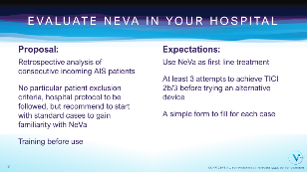 | Wrap up slide.  Relay your key messages and make your ask of the audience. Engage. |  | In summary, NeVa is an innovative device, different from the standard stent retrievers:  - in design,  - and in performance. (We hope to prove this further in the coming months.)  It is the only device WITH DROP ZONES.  It is the only device THAT HAS THE PROMISE OF RECANALIZING REGARDLESS OF CLOT TYPE, including the most challenging organized ones.  It is a device that is TRENDING QUITE IMPRESSIVE EARLY RECANALIZATION RESULTS, and that with a single pass for the majority of cases.  (or good/ or promising/ use the word your audience used to qualify the outcomes when you can/ when it makes sense)  I would like you/ your team to try NeVa and see how it will perform in your hands.  How would you consider doing 10 consecutive cases?
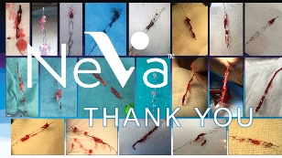 | Stop here and engage discussion. |  | Thank you for your time.  Any questions?
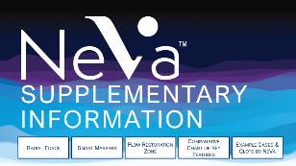 | Supplementary information is there if you had questions during the presentation and you need to enter into the detail of a particular subject, to treat an objection or to answer a question.  Do not systematically present the supplementary slides if you do not have specific questions or objections that necessitate showing them.  All 4 supplementary slides are accessible by clicking on the name of the slide. You’ll see a button on the top right corner of each supplementary information slide that will take you back to this page.  This design is made to avoid you having to talk through data that is irrelevant if you have not had that question.
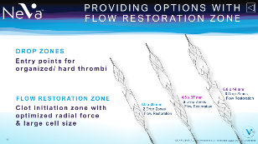 | If you receive a question on the FLOW RESTORATION ZONE |  | Certain NeVa designs have what we call a FLOW RESTORATION ZONE at the proximal edge. This is a stent-like design, similar to existing stent retrievers full body designs. This section was developed with the knowledge retained from the performance of current stent retrievers. Therefore, cell size is larger and radial force is optimized (i.e. expansive radial force which helps clot penetration is very high and compressive radial force is designed to be similar to others). This zone works with the same principle of action as other retrievers.  The FLOW RESTORATION ZONE was an essential feature of our initial range but the performance of our NeVa 4 x 22 without this zone was so good that we wanted to introduce some other designs that have only drop zones. We will be listening to the feedback from our users to make more fine-tuned recommendations on when to use which design, but our current feeling is that the FLOW RESTORATION ZONE will be more relevant in the more proximal occlusions. This is why our single 6.0 mm design includes this zone in its design.
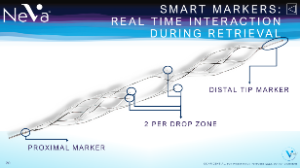 | If you receive a question on the SMART MARKERS |  | SMART MARKERS:  At the leading edge of each of the Drop Zones, these markers give actionable feedback during retrieval. (i.e.: you may not need to wait for 5-7 minutes crossing your fingers that the device is penetrating clot as it should. You will actually be able to work actively to incorporate clot with subtle movements.)
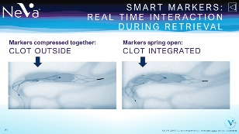 |  |  | The Smart Markers remain open unless they are going through a significantly stenosed area or next to a hard clot. This provides useful information when trying to retrieve the hard clots.  As NeVa is retrieved towards proximal vascular territory, while going next to a hard clot, the device structure may collapse down and you may see the smart markers get together on the angio image. We recommend to slow the pull If this happens and pay close attention.  Once the Drop Zone is right on the clot, the Smart Markers will be at the proximal edge of the clot and will snap open. At this point, we will ask you to release the NeVa pusher wire for a second or two, to allow the structure to relax. This is a good technique to get a hard clot into the Drop Zone.
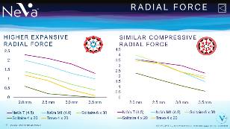 | If you receive a question on the RADIAL FORCE of NeVa… |  | The radial force of NeVa 4.0 x 30 and 4.5 x 37 designs were measured in two different tests that measure two components of the radial force of stent like structures.  The expansive radial force of NeVa is significantly superior to the competing devices, even the 6mm versions.  This type of radial force is necessary to create the initial flow corridor. This is also what pushes on and engages the clot. In this respect, we could expect the flow restoration zone of NeVa to work more effectively on softer range of clots compared to other stent retrievers.  The compressive radial force, on the other hand, is similar, which will mean that shearing effect will be similar to other devices.  Note that the fact that NeVa is closed on both ends and has larger cell size means there is less metal touching the artery wall. This also limits the shearing effect.
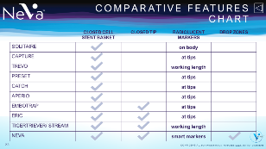 | Visual slide that compares all brands according to their most obvious visible features.  Do not show this unless there is a reason for it.
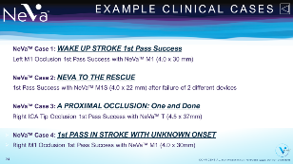 | To use if you are asked to show cases or to use as a closing slide.  Clicking on the case links will take you to the Vesalio website clinical section. This feature will work only if you are connected to the internet.
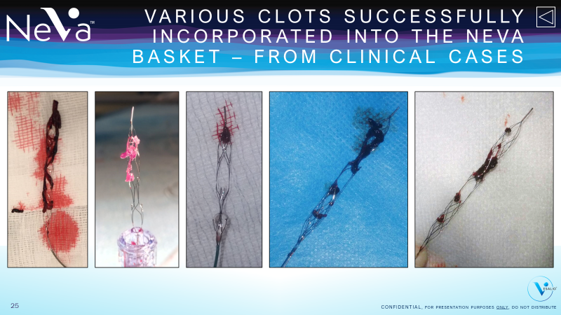 | To use if you are asked to show clot pictures or to use as a closing slide.
